
User Guide
Development Database Server
ADLSV0010
Table of Contents
1 Document Control 2
2 Overview 3
2.1 Disk Drives 3
2.2 SQL Server Instances 3
2.3 Transferring Databases from ADLS0007 3
3 Database Backups 5
3.1 F Drive is for Temporary Backups. 5
3.2 G Drive is for Backups that We Want to Keep 5
4 Permissions 6

Document Control

Date | Author | Version | Notes
17-Jul-2015 | Lief Martin | 0.1 | Notes in Email
24-Jul-2015 | Michael Sautner | 1.0 | For Distribution

Overview
As part of our infrastructure refresh, a new development SQL database server has been created on our new hardware. This server is called ADLSV0010, and replaces ADLS0007. This document outlines the high level configuration of ADLSV0010, provides instructions on moving databased from ADLS0007 to ADLSV0010, storing database backups that need to be kept, restoring databases, and assigning permissions.

Disk Drives
The new database server has 4 logical drives that you can use for databases and database backups.
D – Databases (SAN storage) – 2 TB
E – Databases (QNAP/NAS storage) – 4 TB
F – Temp – 2 TB
G – Archive – 2 TB

Although we haven’t really done any benchmarking, it should be fairly safe to say that SAN storage will be faster than QNAP storage. That said, the amount of SAN storage is a bit more limited. If you are restoring a large database (Coffey and PSI databases are the main culprits), please restore it to the E drive instead.

SQL Server Instances
Same naming convention as the old server, but we don’t have an SQL Server 2005 instance on the new one:
[ADLSV0010\CUSTOMER2008]
[ADLSV0010\CUSTOMER2008R2]
[ADLSV0010\CUSTOMER2012]

Transferring Databases from ADLS0007
The SSMS gui (at least the version LM used for testing) doesn’t let you select a network path when doing a backup, but don’t let that stop you…

You can backup your database from ADLS0007 directly to ADLSV0010 like this:
BACKUP DATABASE [hive_dev_adld0018]
TO DISK = N'\\ADLSV0010\Temporary Database Backups\hive_dev_adld0018.bak'
WITH NOFORMAT, NOINIT, SKIP, NOREWIND, NOUNLOAD, STATS = 10
GO

Restoring the backup is usually easiest through the GUI tools because you need the correct ‘logical file name’ to specify where to put the files. If you do want to use a database script, it will take a couple of steps.

First look up what files are in the backup:
RESTORE FILELISTONLY FROM DISK = N'F:\Temporary Database Backups\hive_dev_adld0018.bak'

Then restore the database:
RESTORE DATABASE [hive_dev_adld0018]
FROM DISK = N'F:\Temporary Database Backups\hive_dev_adld0018.bak'
WITH RECOVERY
, FILE = 1
, MOVE 'hive_dev_adld0018' to 'D:\Databases - 2012\hive_dev_adld0018.mdf'
, MOVE 'hive_dev_adld0018_log' to 'D:\Databases - 2012\hive_dev_adld0018_log.ldf'
, NOUNLOAD
, STATS = 10

For those that need to transfer large databases, the above database is about 150GB. It took 105 minutes to backup across the network, and then 60 minutes to restore.

After your database has finished restoring, you’ll need to wait up to a minute before you can access it.

The issue is that when you restore the database, although it sets the person that restored the database as the owner in the sys.databases table, it doesn’t set the dbo user in the database to link to their account (it leaves it as “whatever it was in the backup”, which mostly means something that is invalid unless you’re restoring to the same server as the backup came from). We’re using a SQL Agent job that runs once a minute that *should* fix it. It’s new though, so, there’s might be a few cases that it doesn’t handle correctly.

Database Backups
It is not feasible to back up the entire database server, and databases that are attached to the database server are not backed up. Having said that, new database server has significant redundancy built in, and will be significantly more reliable than ADLS0007, however if you have a database that you cannot afford to lose, either because you have spent significant effort configuring it, or a copy would need to be obtained from a customer, please store a compressed copy in the archive folder (see Section 2.2).

F Drive is for Temporary Backups.
Emphasis on temporary. This drive is to be used for the purpose of restoring databases only. Please delete databases from this folder once they have been restored.

Note that Subnet have set up a maintenance script for us that runs daily, and removes files older than two weeks.

You can place files on this drive using the network share: \\adlsv0010\Temporary Database Backups

G Drive is for Backups that We Want to Keep
Database backups that are stored on the G drive will not be deleted automatically, and will be backed up to tape.

There are two folders on this drive – one for developer databases (general use), and one for customer databases (for I&S to keep copies of backups from customers).

We all have read access to both folders, but most of us will only have write access to the developer databases folder.

Please ensure that database backups are compressed before saving them to these folders. Note that when backing up from ADLSV0010, databases will be automatically compressed.

You can access files in these folders using the network shares: \\adlsv0010\Development Database Archive and \\adlsv0010\Customer Database Archive

Permissions
We’re trying something different from the previous server. Rather than having sysadmin privileges on the database server, we’ve got the db_creator role.

This means that you won’t automatically have rights to ALL databases on the server. Instead, you’ll need to ask the person that ‘owns’ the database to either give you permissions, or make a backup for you. It also means that you know that no one else is using your databases unless you gave them access.

It also means that you don’t need to use silly names like “QESTLab_LM_DO_NOT_TOUCH_THIS_DATABASE!$!$!#@#$!%!$” to keep people away from your precious databases. Yay!

Note that when we undertake database cleanups (i.e. deletion of databases that are no longer required), we will be checking with the database owner, so please make sure that the owner is aware if you are using their database.

To give other people access to your database, you can do so by adding them as a user, and assigning the appropriate rights:
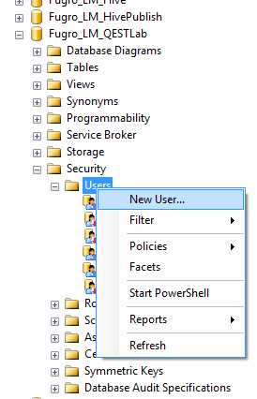
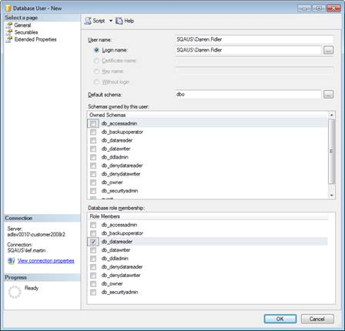

You do not need to (and won’t be able to) create a SQL server login for them. Everyone that needs access to the database server will be a member of the “SQAUS\SQL Users” group, so they’ll be able to log in and access the database just fine.

You can see who owns each database (along with a bit of additional information) using the following SQL query:
select [SQL Instance] = @@SERVERNAME
, [Database] = db.name
, [Owner] = SUSER_SNAME(db.owner_sid)
, [Created Date] = db.create_date
, [Recovery] = lower(db.recovery_model_desc)
, [Size (MB)] = SUM(f.size) / 128
from sys.databases db
inner join sys.master_files f on db.database_id = f.database_id
where db.name not in ('master', 'model', 'msdb', 'tempdb', 'ReportServer$') and db.is_distributor = 0
group by db.database_id, db.name, db.owner_sid, db.create_date, db.recovery_model_desc
order by db.name
(the where clause is just to exclude the system databases)

If you want to transfer ownership of a database to someone else, you’ll need a sysadmin to run the following:
alter authorization on database::[database_name] to [SQAUS\user.name];

At present, Darren, Benny, Krzysztof and Lief have access to sysadmin logins.

For sysadmins – note that the alter authorisation statement can fail with the following error message:
Msg 15110, Level 16, State 1, Line 1
The proposed new database owner is already a user or aliased in the database.
Usually this just means that the new owner was explicitly added as a user to the database.
You can look it up with:
select Name from [database_name].sys.sysusers where sid = SUSER_SID('SQAUS\user.name')
And drop it with:
use [database_name]
drop user [Name]

If you are using an old version of SSMS (like LM), you will not be able to view the “Database Properties” page for databases on the CUSTOMER2012 instance, and will get the following error message instead:
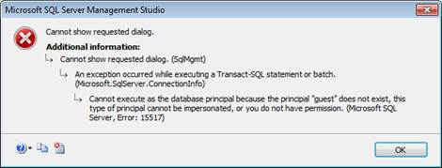
The simple fix is to install a newer version of SSMS (and the other client components if you want them): \\adls0003\Installs\Restricted\Microsoft SQL Server 2012 Developer



Spectra QEST Australia Pty. Ltd.
Suite 7, 132 O’Connell Street
North Adelaide, SA 5006
Australia
+61 8 8360 8900
Spectra QEST America Corp.
5170 Golden Foothill Parkway
El Dorado Hills CA 95762
United States
+1 888 360 8901
www.spectraqest.com

